**WHAT IS HAPPENING IN THE PICTURE?**

**Name________________ class__________**

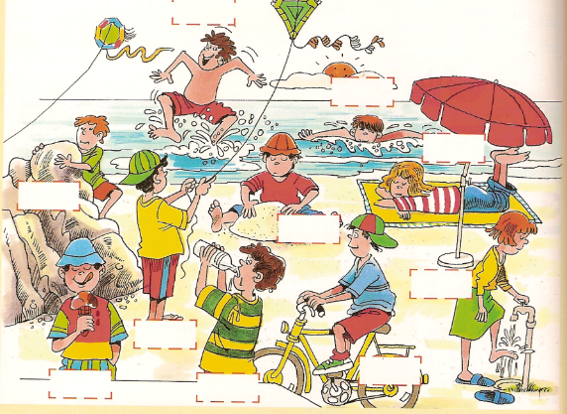

Ron

Mark

Rose

Adam

Dan

Dana

Jack

Matt

Tim

Eric

**.**

1

**Look at the picture and complete the sentences. (***Present continuous***)**

1. Jack is__________ 6. Mark is________________

2. Ron is_____________ 7. Matt is_________________

3. Tim is______________ 8. The kids are_______________

4. Rose is______________ 9. The girls are not_______________

5. Dana is _____________ 10. The kids are not _______________

2

**Write 5 sentences to describe the picture above.**

1.____________________________________________

2.____________________________________________

3.____________________________________________

4.____________________________________________

5.____________________________________________